**Wireframe Document**

**Swiggy Bangalore Data Analysis**



**Revision Number - 1.2**

**Last Date of Revision - 03/07/2022**

**Shashank Nishad**

WIREFRAME DOCUMENT DESIGN

**Document Control**

|  |  |  |  |
| --- | --- | --- | --- |
| **Date** | **Version** | **Description** | **Author** |
|  |  |  |  |
| 19/06/2022 | 1.0 | Introduction, | Shashank Nishad |
|  |  | Problem Statement |  |
|  |  |  |  |
| 26/06/2022 | 1.1 | Dataset Information, | Shashank Nishad |
|  |  | Architecture |  |
|  |  | Description |  |
|  |  |  |  |
| 03/07/2022 | 1.2 | Final Revision | Shashank Nishad |
|  |  |  |  |
|  |  |  |  |



**2 |** P a

g e H e a r t D i s e a s e D i a g n o s t i c A n a l y s i s

WIREFRAME DOCUMENT DESIGN

**We Performed Exploratory Data Analysis on Jupyter Notebook and then created a Power BI Desktop Dashboard.**

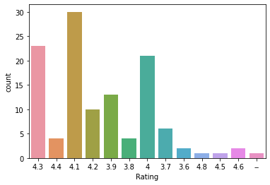

**Now we check the rating by count the total number of buying behaviour of a people there are most number of rating is 4.1 and 30 user rating 4.1.**

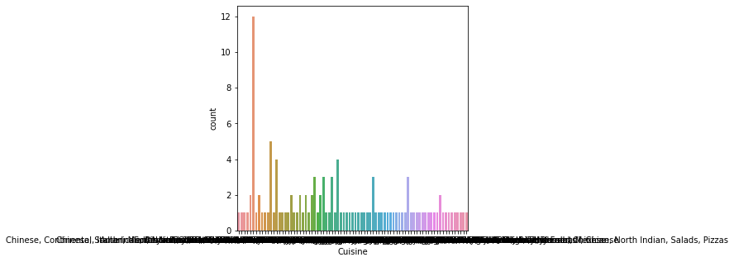

**in countplot show which product more sell in the market by count.**

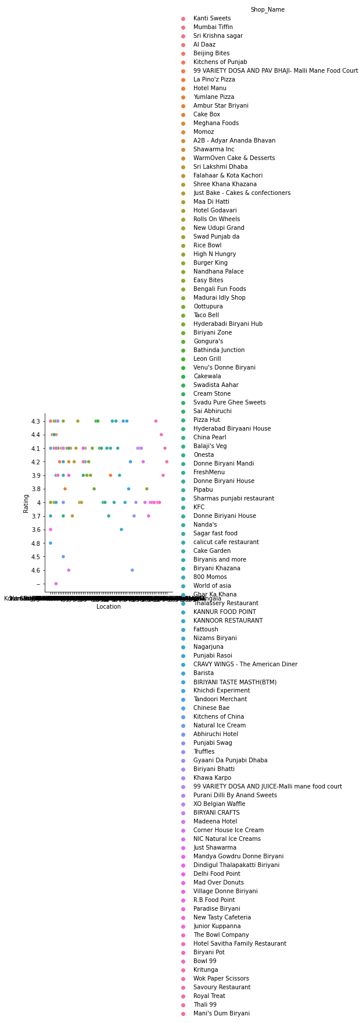

**Now above graph show location by rating the graph is very spread.**

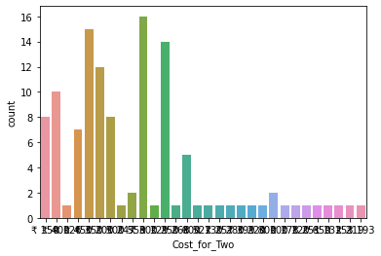

**Now we count the price of two product**

In [32]:



